Identifying Campus Partners Worksheet
Part 1: Build Your Core Team
Role | Responsibilities | Check-in Frequency
PI:

Co-PI(s):

Senior Personnel:

Supporting Administrator(s):

Administrative Assistance:

Budget Manager(s):

Financial Aid Office:
External Evaluator:
Institutional Research:

NSF Program Officer:
Other:

Part 2: Create Your On-Campus and Online Presence
Tool | Campus Contact(s) | Notes
Website
Program Email
Flyers/Banners/Etc.
Press Releases
Social Media Platforms
Data Management/ Data Storage
Graphic Design
Other



Part 3: Scholar Recruitment, Selection, and On-boarding
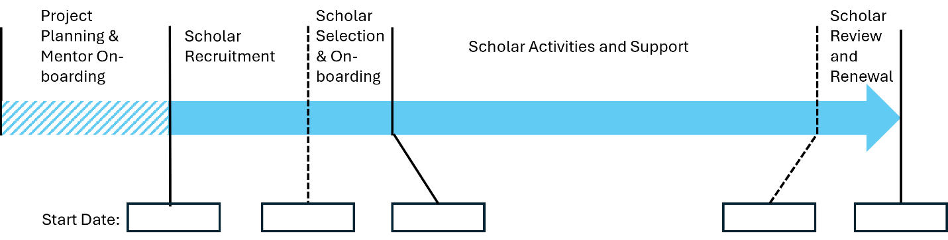
Goal | Campus Contacts | Timeline/Lead
Recruitment of Potential Scholars – Internal
Recruitment of Potential Scholars – External
Print/Publish Brochures, Flyers, Images, etc.
Application Distribution/ Publishing
Financial Aid Eligibility Review
Awarding Scholarships
Housing and Registration
Other

Part 4: Scholar Activities & Support
Activity | Campus Contacts | Timeline/Lead
Room Reservations
Supplies for Activities
Student Transportation
Course Registration
Speakers/Tours/Travel

Part 5: Review, Reporting & Dissemination of Knowledge
Activity | Campus Contacts | Timeline/Lead
Institutional Review Board
Institutional Research (Tracking GPA, Retention, Completion, Surveys, Focus Groups, etc.)
Annual Reporting
External Evaluator Activities
Conferences, Publications, and Organizations for Dissemination
Other

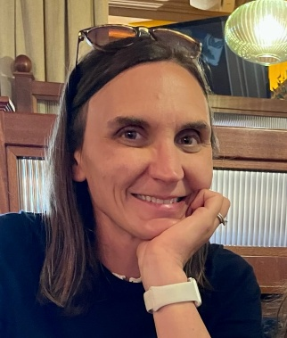
Patricia Foley, Ph.D.
Professor and Chair, Engineering
S-STEM Program Director
College of the Canyons
Valencia, CA 91355
Patricia.foley@canyons.edu

